* **Sample Code Explanation Results - C# and JavaScript**

**User Instruction:**

Please explain the overall code in bullet points. Do not explain line by line code. Avoid the repetition.

------------------------------------------------------------------------------------------------------------------------------------------

1. JavaScript code::

function getSong(){

fetch(api)

.then(response => {

return response.json();

})

.then(data => {

console.log(data);

song.title = data.now_playing.song.title;

song.artist = data.now_playing.song.artist;

song.bitrate.high = data.station.mounts[0].bitrate;

song.url.high = data.station.mounts[0].url;

song.bitrate.low = data.station.mounts[1].bitrate;

song.url.low = data.station.mounts[1].url;

})

.then(() => {

displayInfo();

})

.catch(error =>{

songTitleElement.innerText = error.message;

});

}

Time – 6 seconds

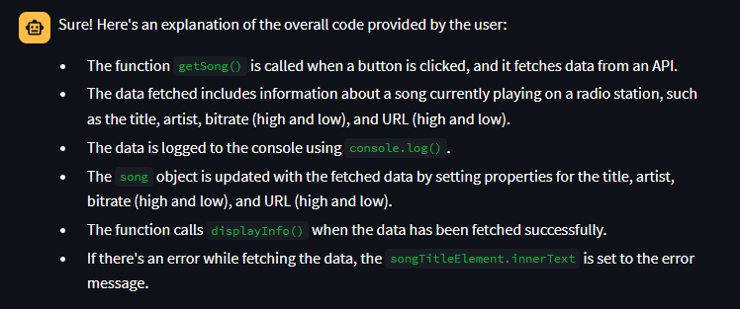

1. JavaScript code:

function getWeather(myLat, myLong){

let link = `${myApi.proxy}https://api.openweathermap.org/data/2.5/weather?lat=${myLat}&lon=${myLong}&appid=${myApi.key}`;

fetch(link) //send a network request and get the information from the server

.then(response => {

let data = response.json(); //now whatever response we get, parse it into json and store in data

return data;

})

.then(data => { //then we update our weather object with the required data

// console.log(data);

weather.temperature.value = Math.floor(data.main.temp - KELVIN);

weather.description = data.weather[0].description;

weather.iconID = data.weather[0].icon;

weather.city = data.name;

weather.country = data.sys.country;

weather.humidity = data.main.humidity;

})

.then(() => { //then display the weather to the ui

displayWeather();

});

}

Time – 6 seconds

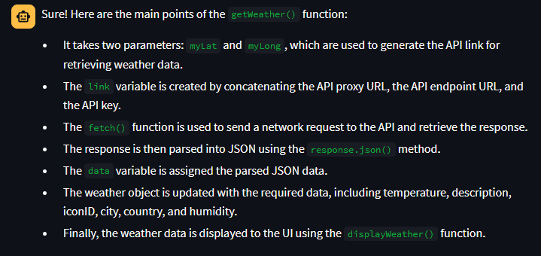

1. JavaScript Code:

//DOM Elements

const playButton = document.getElementById('btn-play');

const pauseButton = document.getElementById('btn-pause');

const resetButton = document.getElementById('btn-reset');

const timer = document.querySelector('.timer');

// CONVERTING TIME TO STRING

function timeToString(time){

// assume time is 10000000 ms, then

let differenceInHours = time / 3600000; // 2.777

let hr = Math.floor(differenceInHours); //2

let differenceInMinutes = (differenceInHours - hr)*60; // 46.666

let min = Math.floor(differenceInMinutes); // 46

let differenceInSeconds = (differenceInMinutes - min)*60; // 39.99

let sec = Math.floor(differenceInSeconds); // 39

let differenceInMilliseconds = (differenceInSeconds - sec)*100; //99.99 /* multiplied it by 100 not 1000 to make it two digit */

let ms = Math.floor(differenceInMilliseconds); // 99

//but we want our format to be 02:46:39 , not 2:46:39 ---> for that use padStart()

let formattedmin = min.toString().padStart(2, '0');

let formattedsec = sec.toString().padStart(2, '0');

let formattedms = ms.toString().padStart(2, '0');

//now we can return the time in required format

return `${formattedmin}:${formattedsec}:${formattedms}`;

}

let startTime;

let elapsedTime = 0;

let timerInterval;

function displayInTimer(str){

timer.innerHTML = str;

}

function play(){

startTime = Date.now() - elapsedTime;

timerInterval = setInterval(function printTime(){

elapsedTime = Date.now() - startTime;

displayInTimer(timeToString(elapsedTime));

},10);

toggleButtons("PAUSE");

}

function pause(){

clearInterval(timerInterval);

toggleButtons("PLAY");

}

function reset(){

clearInterval(timerInterval);

displayInTimer('00:00:00');

elapsedTime = 0;

toggleButtons("PLAY");

}

function toggleButtons(Key) {

if(Key === 'PLAY'){

playButton.style.display = 'block';

pauseButton.style.display = 'none';

} else {

playButton.style.display = 'none';

pauseButton.style.display = 'block';

}}

//EVENT LISTENERS

playButton.addEventListener('click', play);

pauseButton.addEventListener('click',pause);

resetButton.addEventListener('click', reset);

Time – 14 seconds

1. C# Code::
2. *\*/*
3. **using** System;
4. **class** Program
5. {
6. **static** **void** Main()
7. {
8. Console.WriteLine("Enter the Base : ");
9. **double** num = **double**.Parse(Console.ReadLine());
10. Console.WriteLine("Enter the First Exponent :");
11. **double** exp1 = **double**.Parse(Console.ReadLine());
12. Console.WriteLine("Enter the Second Exponent :");
13. **double** exp2 = **double**.Parse(Console.ReadLine());
14. **double** mul;
15. mul = exp1 + exp2;
16. Console.WriteLine("Result is : {0}^{1} : {2}", num, mul, Math.Pow(num, mul));
17. Console.ReadLine();
18. }
19. }

Time – 9 seconds

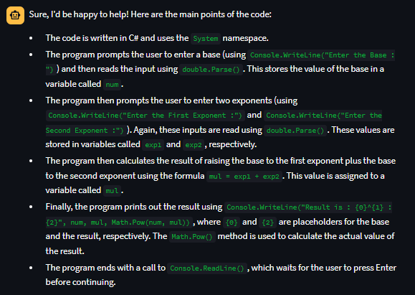

2. c# code ::

**using** System;

**class** linSearch

{

**public** **static** **void** Main()

{

Console.WriteLine("Enter Number of Elements you Want to Hold in the Array? ");

**string** s = Console.ReadLine();

**int** x = Int32.Parse(s);

**int**[] a = new **int**[x];

Console.WriteLine("Enter Array Elements :");

**for** (**int** i = 0; i < x; i++)

{

**string** s1 = Console.ReadLine();

a[i] = Int32.Parse(s1);

}

Array.Sort(a);

Console.WriteLine("Sorted Array : ");

**for** (**int** i = 0; i < x; i++)

{

Console.WriteLine("{0}", a[i]);

}

Console.WriteLine("Enter the Element to be Searched : ");

**string** s3 = Console.ReadLine();

**int** x2 = Int32.Parse(s3);

**int** x3 = Array.BinarySearch(a, (**Object**)x2);

Console.WriteLine("BinarySearch: " + x3);

Console.WriteLine("Element {0} is {1}", x3, a[x3]);

Console.Read();

}

}

Time : 28 Seconds

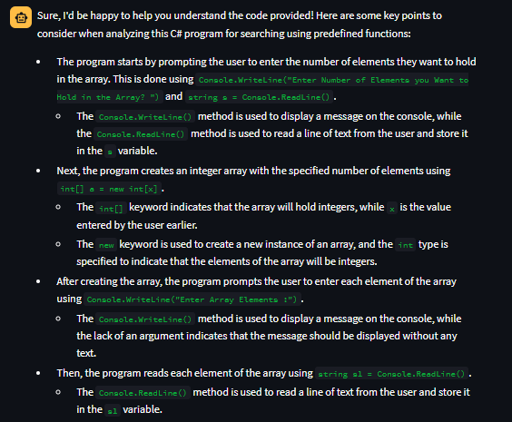

3.c# code::

1. */\**
2. *\* C++ Program to Change the Case of given Alphabetical Character*
3. *\*/*
5. #include<iostream>
6. #include<cctype>
7. using namespace std;
9. int main()
10. {
11. char c;
13. cout << "Enter the character : ";
14. cin >> c;
16. if (!isalpha(c))
17. cout << c << " is not an alphabetical character." << endl;
18. else
19. {
20. int case_val;
21. if (c >= 'a' && c <= 'z')
22. {
23. c = c - 'a' + 'A';
24. case_val = 1;
25. }
26. else if (c >= 'A' || c <= 'Z')
27. {
28. c = c + 'a' - 'A';
29. case_val = 0;
30. }
31. cout << c << " is the " << ( (case_val == 1) ? "upper" : "lower" )
32. << " case of given character " << endl;
33. }
34. }

Time: 9 Seconds

